Corbin Veitch, David Melanson

Computer Engineering Lab III (CPE-427-01)

Tech Memo Lab 2

Fall 2023

This lab had two goals. First, was to send and receive characters interchangeably from ASCII to hex and vice versa using USART communication protocols. Second, to use USART to fill on board EEPROM and subsequently send it to the PuTTY terminal of a computer as validation.

The first task was attempted initially porting code from ATMEGA 8515 from last year’s course unsuccessfully. Upon using the code supplied, the expected results were achieved. The second was achieved in short order after.

Multiple issues were faced in completing the lab. As mentioned, the code from the previous year was not able to provide the results desired for USART communication. After these issues were solved the EEPROM portion worked as it was supposed to, with the changing of a fuse to hold the values in EEPROM after powering the board down.

In summary, despite experiencing some initial issues, the USART and EEPROM it was possible to achieve the results desired for the exercise.

Appendix

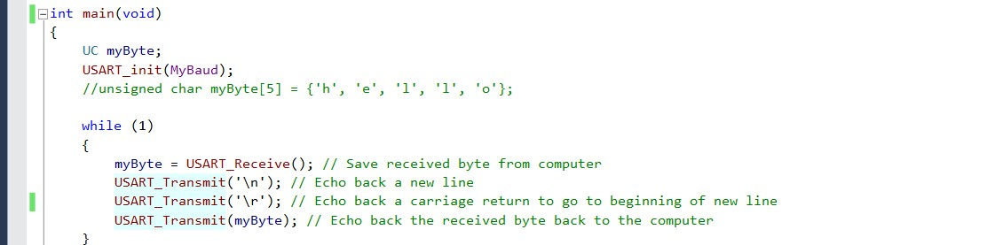

Figure : Code for USART transmission and reception

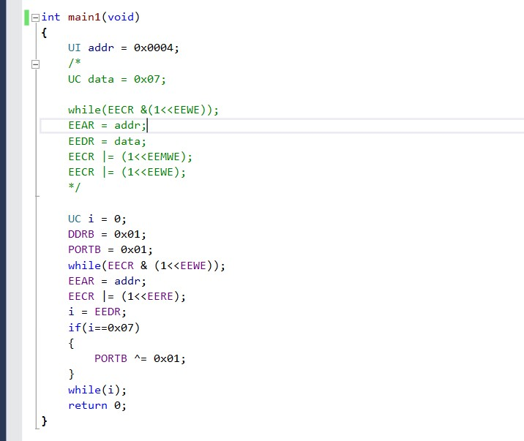

Figure : Code for writing to EEPROM using USART, commented out part is initial transfer, non-commented is validation.

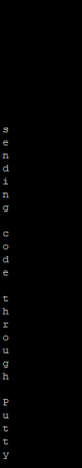

Figure : Sending and receiving text through PuTTY validated.